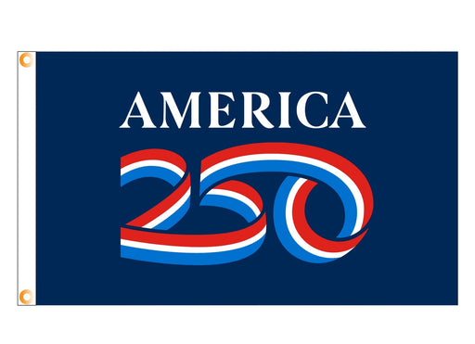America’s 250th Anniversary Outdoor Garden Flag 12”X18”
- The ONLY Officially Licensed 250th Anniversary Flag Licensed by the Federal Government and made by Annin Flagmakers.
The Union250 Committee is raising funds for 2026 town events.
These flags are available for $30.00 each.
Contact the Selectman’s Office at (860)684-3812 or unionadmin@unionconnecticut.org
Payment is due at the time of ordering, cash or check payable to “Union250.”
-----------------------------------------------------------------------------------------------------------------

ORDER FORM – COMPLETE & SUBMIT TO SELECTMEN’S OFFICE
BY APRIL 30

Name: _________________________________________________

Phone:_________________________________________________

Address:_______________________________________________

Enclose an amount of $30 per flag, cash or check payable to “Union250”

